**Response Monitoring Service Invoice Lobby Elements**

|  |  |  |  |  |
| --- | --- | --- | --- | --- |
| **Ver** | **Date** | **Author** | **Comments** | **Reviewed by** |
| 1 | 09/03/2021 | Tom Bell | CRIM 0550 | TBC |
|  |  |  |  |  |

Requirements 2

Prerequisites 2

Solution Overview 2

Solution Details 2

Security 3

Companies 3

Data Migration 3

Test Steps 3

Technical Implementation 3

Requirements

Two additional columns are required on the Service Contract screen and two lobby elements are required in the Credit Manager lobby that display the Service Contracts that are due and overdue for invoicing.

Solution Overview

**Invoice Parameters Additional Columns (Service Contract screen)**

* Column for “Invoice ID”
* Column for “Period Fully Invoiced?”

**Lobby Filter for Contract Type**

* Credit Manager Lobby must have a filter to filter by Contract Type.

**Response Monitoring Service Contracts Due Invoices Lobby Element**

* Lobby Element to show all Service Contracts that are due for invoicing.

**Response Monitoring Service Contract Overdue Invoices Lobby Element**

* Lobby element to show all Service Contracts are overdue for invoicing.

Solution Details

Service Contract screen – Invoice Parameters tab Columns

* Column for Invoice ID (Invoice Series and Invoice No. concatenation)
* Column “Period Fully Invoiced?”

The above columns are required in the Service Contract screen, Invoice Parameters tab. Highlighted in red is where the columns should be located.

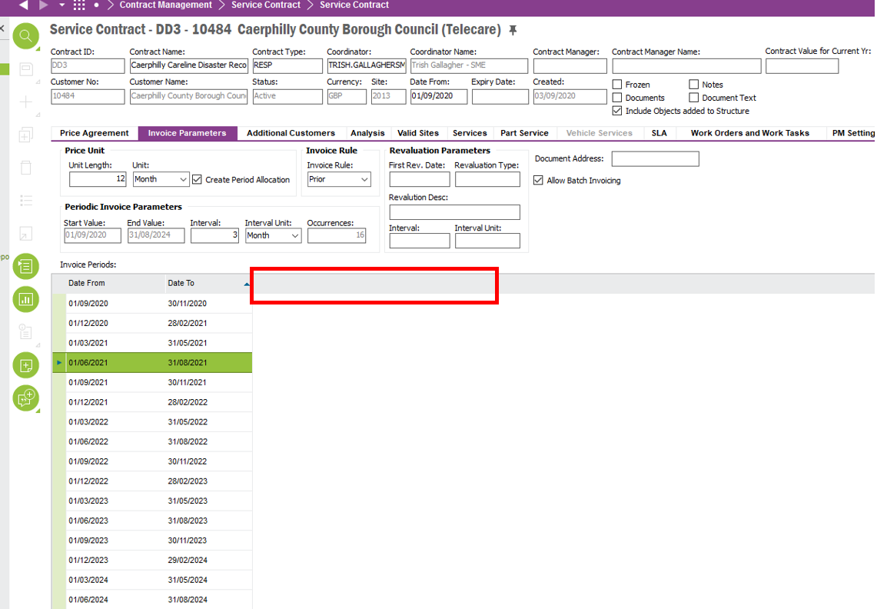

The below section will detail these columns in more detail.

# Column for Invoice ID

This column must show a concatenation of Invoice Series ID and Invoice No. For each Invoice Plan Details Line, there must be an Invoice Series and Invoice No. separated by a comma captured in this field. An example is shown below of what the column must look like.

|  |
| --- |
| **Invoice ID** (Invoice Series ID + Invoice No.) |
| CD3487232, CD50339834, CD45930432 |

The below section will detail where the data is located.

The below screenshot shows the Invoice No. from the Invoice Plan Details screen. The Invoice Number for the corresponding Invoice Period must appear in this column.

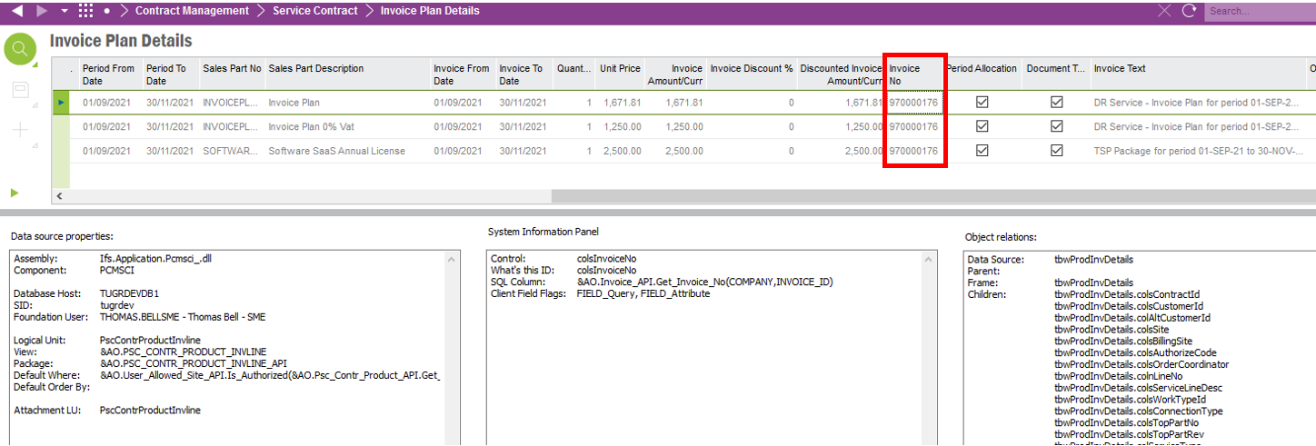

The Invoice Series ID must also be displayed in this column.

The Invoice Series ID data (red box) can be found on the Customer Invoice screen. The Series ID must be for the linked Invoice Number (shown in blue from the Invoice Plan Details screen).

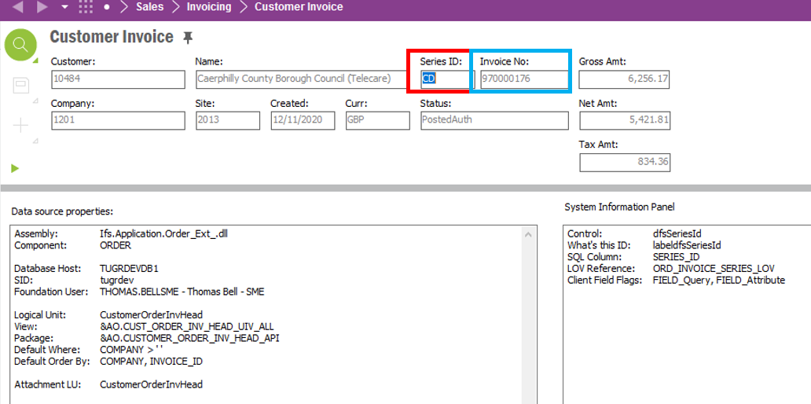

# Column “Period Fully Invoiced?”

A column must exist that checks if all Invoice Plan Detail Lines (shown in the below screenshot) have an Invoice No. populated in the Invoice No. field.

If all Invoice No fields are populated, then the check box is TRUE for the corresponding Invoice Period. If not all Invoice No fields are populated then the checkbox is FALSE.



Lobby Elements and Lobby Filters

# Lobby Filter

A lobby filter must exist on the Credit Manager Lobby that filters the lobby by Contract Type.

The below screenshot shows the field that needs to filterable in the lobby.

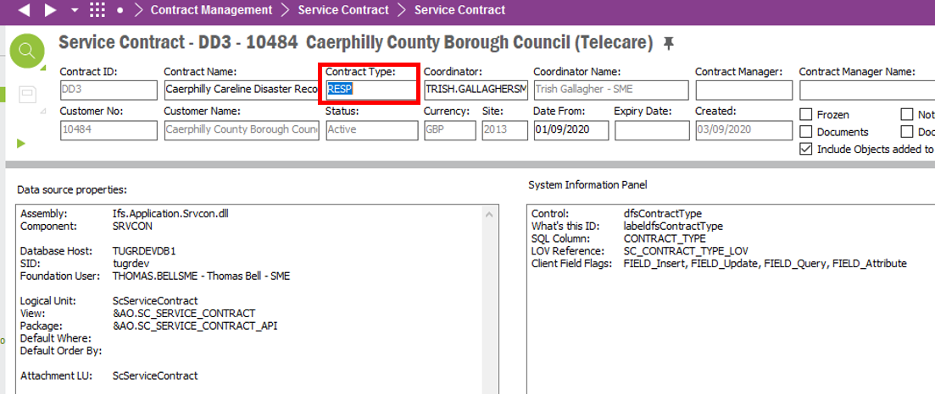

# Due Response Monitoring Service Contracts - Lobby Element

* Lobby Element to show all Service Contracts that are due for payment.

The lobby element tile must show the number of Service Contracts. When clicking into the tile the user is brought a list of Service Contracts, that when clicked bring the user to the Service Contract screen for the Service Contract ID that was selected. The columns in the lobby element are as follows.

* Contract ID (from Service Contract screen)
* Contract Name (from Service Contract screen)
* Customer No (from Service Contract screen)
* Customer Name (from Service Contract screen)
* Date To (from Service Contract screen, Invoice Parameters, Date to Field)

The below screenshot shows the “Date To” field in the Service Contract screen, Invoice Parameters tab in red.

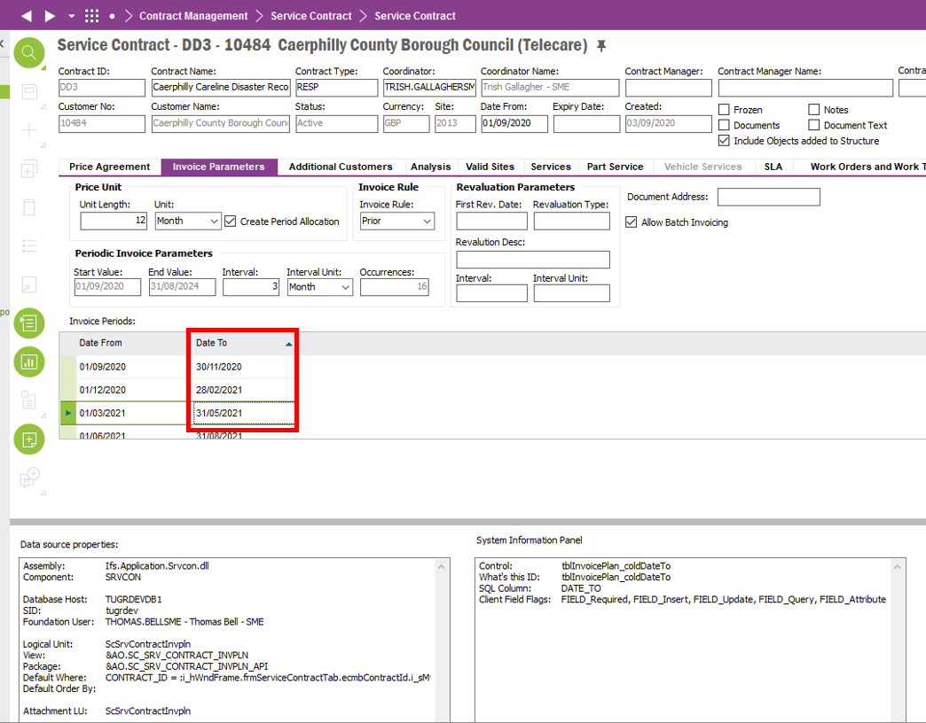

If the Date To field MONTH is equal to TODAY’S month and the Invoice Plan Details screen does not have an Invoice Number on all Invoice Plan Detail Lines then then the lobby element must show the Service Contract.

**NOTE**: can also use the “Period Fully Invoiced?” check box that is part of this spec. This check box checks whether all Invoice No’s have been populated in this screen. If check box is false and Date To field month is equal to TODAY’S month, then show the Service Contract in lobby element

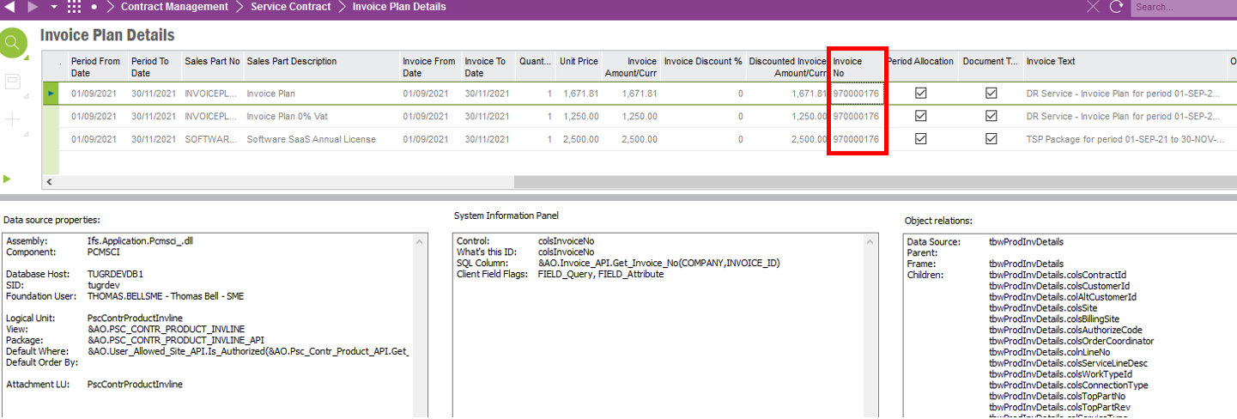

**Summary**

The lobby element must display the Service Contracts that meet BOTH criteria below.

* Service Contract screen Invoice Period tab the “Date To” field MONTH is in the same month as today’s date.
* AND where the “Period Fully Invoiced?” check box is FALSE (not in system, part of this spec).

# Response Monitoring Service Contracts Overdue Invoices Lobby Element

* Lobby element to show the Service Contracts that have Invoice Dates passed but no invoices have been generated.

The lobby element tile must show the number of Service Contracts in the lobby element. When clicking into the tile the user is brought a list of Service Contracts, that when clicked bring the user to the Service Contract screen for the Service Contract ID that was selected. The columns in the lobby element are as follows.

* Contract ID (from Service Contract screen)
* Contract Name (from Service Contract screen)
* Customer No (from Service Contract screen)
* Customer Name (from Service Contract screen)
* Date To (from Service Contract screen, Invoice Parameters, Date to Field)

The below screenshot shows the Service Contract, Invoice Parameters “Date To” field in red below.



The below screenshot shows the Invoice Plan Details screen. If all Lines on this screen do not have an Invoice ID populated AND if the “Date To” field (shown above) has passed. Then the Service Contract must appear in the lobby element.

**NOTE**: can also use the “Period Fully Invoiced?” check box that is part of this spec. This check box checks whether all Invoice No’s have been populated in this screen. If the checkbox is false and the Date To field has been passed then show the Service Contract in this lobby element.



**Summary**

The lobby element must display the Service Contract that meet **BOTH** criteria below.

* Service Contract screen Invoice Period tab “Date To” field is less than today’s date. (Date To field has passed today’s date.
* AND where the “Period Fully Invoiced?” check box is FALSE (not in system, part of this spec).

**Technical.**

Field Definitions.

<New Field/CLU Definition>

|  |  |  |  |  |  |  |
| --- | --- | --- | --- | --- | --- | --- |
| New DB Object Name | DB Object Item/Field Names | Item Description | Item Data Type | Item Syntax | Calculation Spec, if Derived | LOVs/Enums/Is Mandatory? |
|  |  |  |  |  |  |  |
|  |  |  |  |  |  |  |
|  |  |  |  |  |  |  |
|  |  |  |  |  |  |  |
|  |  |  |  |  |  |  |
|  |  |  |  |  |  |  |
|  |  |  |  |  |  |  |
|  |  |  |  |  |  |  |
|  |  |  |  |  |  |  |
|  |  |  |  |  |  |  |
|  |  |  |  |  |  |  |
|  |  |  |  |  |  |  |

Security

<Define security controls> (Who needs access to this and will it be restricted from any other users etc)

Auto Populate for All Users.

**Default Advanced Invoice Tax Code Field** - Create, Edit and Delete privileges for Financial Accounts.

Companies

Applies to the following companies. All.

|  |  |
| --- | --- |
| **Company** | **Required (Y/N)** |
| 1201 | Y |
| TBC |  |
|  |  |

Data Migration

<Describe any data migration impacts this development may have – i.e additional data to be migrated>

Test Steps

<Steps that needs to be taken to test this change. Please provide expected results> Updated post solution.

|  |  |  |
| --- | --- | --- |
| **No** | **Script\Test Steps** | **Expected Result** |
| 1 |  |  |
| 2 |  |  |
| 3 |  |  |
| 4 |  |  |
|  |  |  |
|  |  |  |

Technical Implementation

<Completed by the technical developer - Technical solution, list packages, functions, Custom menus created etc >

# Delivery Notes

1. The related configurations are under the “EA_Finance” Application Configuration Package (ACP).
   * Deploy the EA_Finance package by clicking on “Publish”.
2. Go to the “Service Contract” window, under “Invoice Parameters”,
   * Applying the configurations.
     1. RMB on the table body “Invoice Periods”.
     2. Hover over “Custom Objects” menu and click in the “Reload Configuration” menu.
     3. A “Question” window will pop up, click the “OK” button within the window.
   * Adding the related columns.
     1. RMB on the table header “Invoice Periods”.
     2. Click on the “Column Chooser” menu.
     3. Under the “Hidden Columns” box select the 2 columns, “Invoice Id” and “Period Fully Invoiced”.
     4. By clicking the “Single Right Arrowhead” button, add the selected columns to the “Visible Columns” box and click “OK” when done.
3. Grant permissions to “Credit Manager” lobby.
   * Permission sets: IFS_ALL
4. Lobby Parameters:

* Company
* Site
* Contract Type

1. Lobby elements

|  |  |  |
| --- | --- | --- |
| **Element name** | **Custom Function** | **Remarks** |
| Due Response Monitoring Service Contracts | N/A |  |
| Overdue Invoices Response Monitoring Service Contracts | N/A |  |